07 BANK DATABASE – SQL VIEWS
2520030034
P. Pratik Kumar
- Customer + Account View
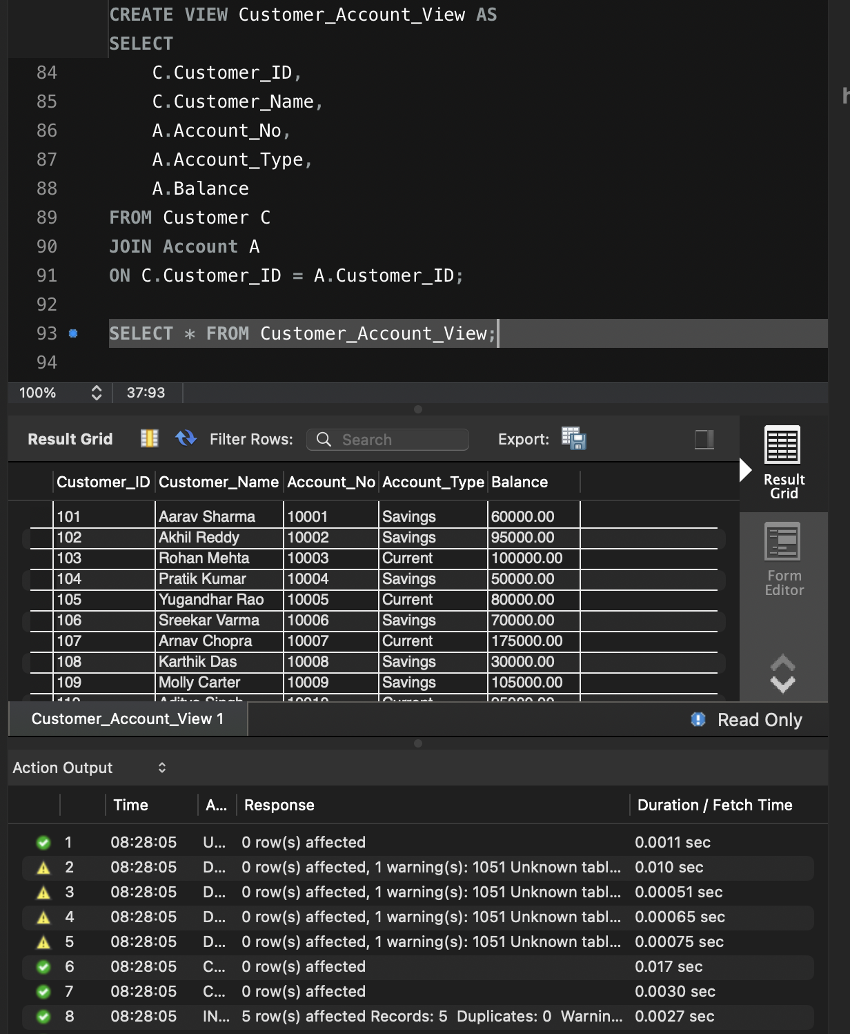

- Savings Accounts > ₹50,000
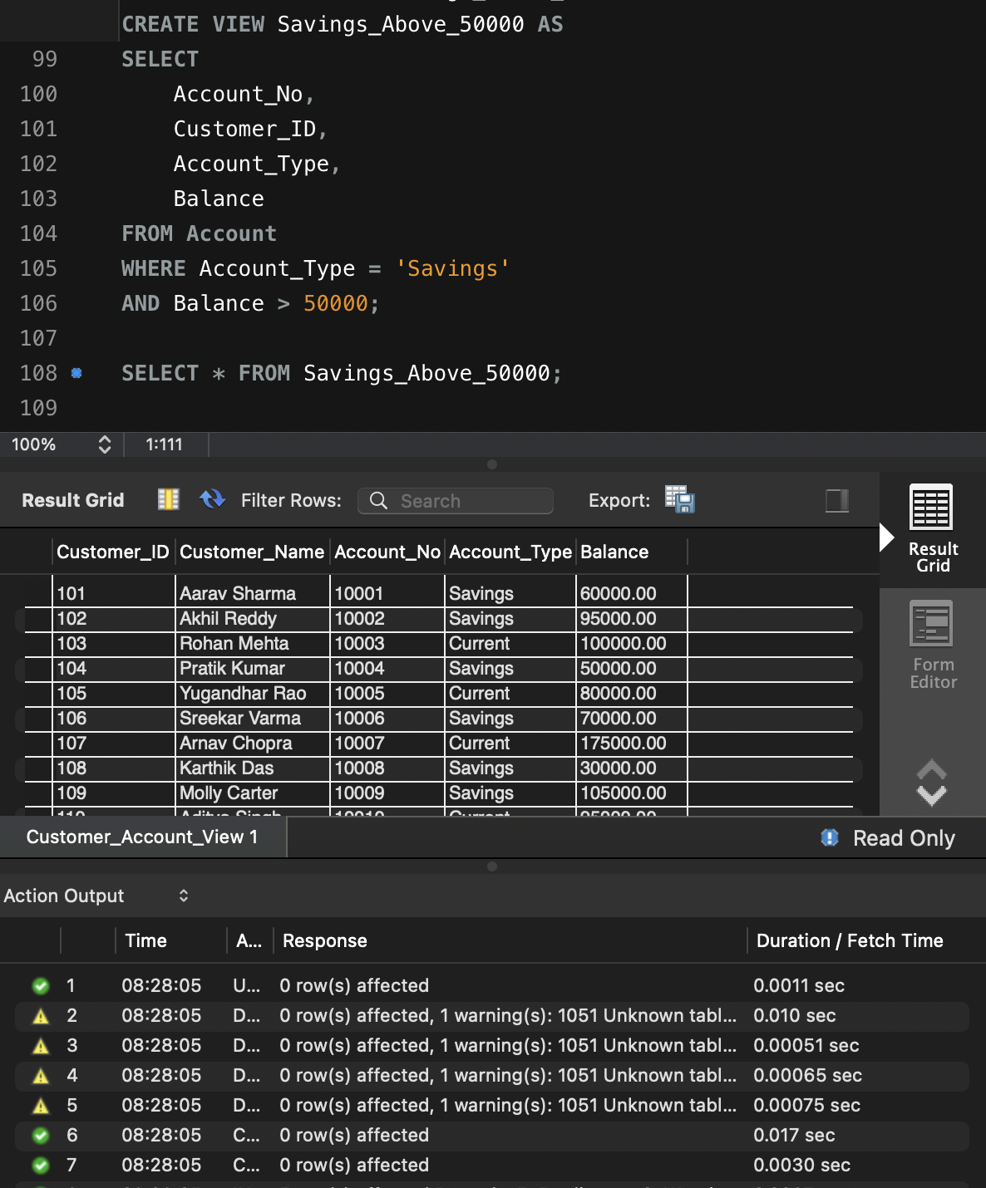

3. Customer + Account + Loan View
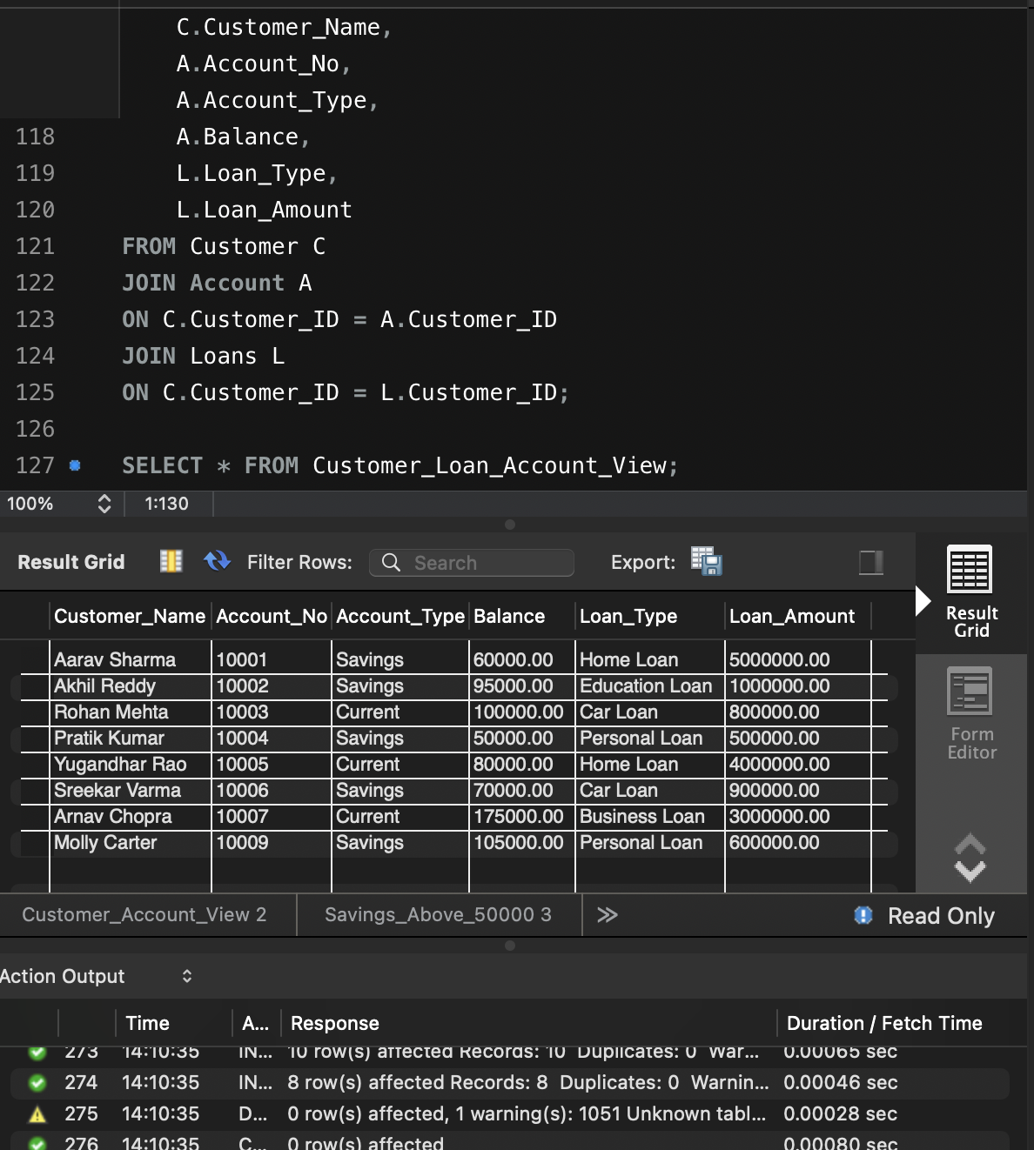
- Branch-Wise Total Balance
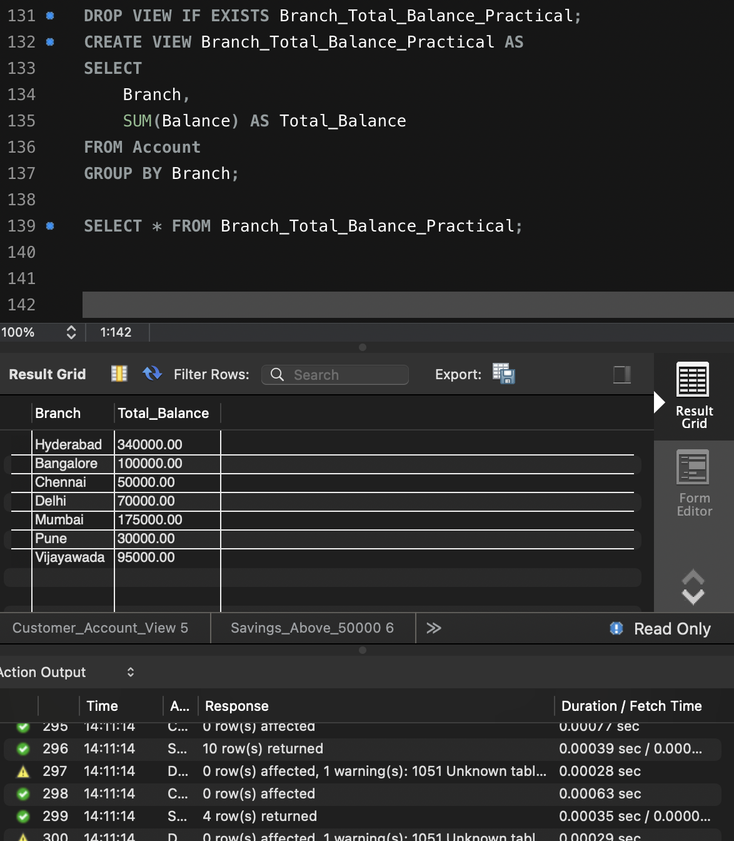

5. Annual Loan Interest
